Motion Planning Assignment 3

Submitted by: Purna Patel

WPI ID: 150062312

**D* Algorithm:**

* D* or Dynamic A* keeps track of both current h and the best h value that is k.
* Initially D* starts exploring from goal to start and when initial path is found, all the path nodes will have their respective k values which serves as a “sort of heuristic” during replanning.
* When a dynamic obstacle is detected, the h values of the affected nodes become infinite, and those nodes are added to open list.
* The algorithm again starts exploring from minimum k value node in the open list, thus from the very first effected node of the original path.
* The k value helps keep track of original path so during replanning, the algorithm only replans the effected nodes and tries to connect it to the original path.
* Due to this replanning of whole path is avoided and thus D* replans faster than A* or Dijkstra.
* Following were the results obtained by running the D* algorithm for given scenarios.
* **Map 1**

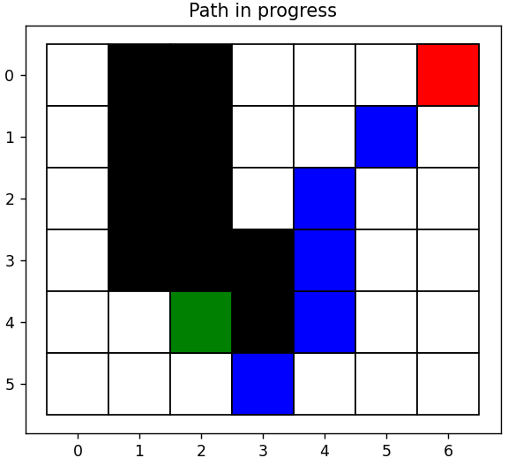

* **Map 2**

* The last dynamic obstacle was detected when it reached the goal.
* It can be seen in the third graph that how the algorithm replanned and connected the new path to the original path.
* **Map 3**

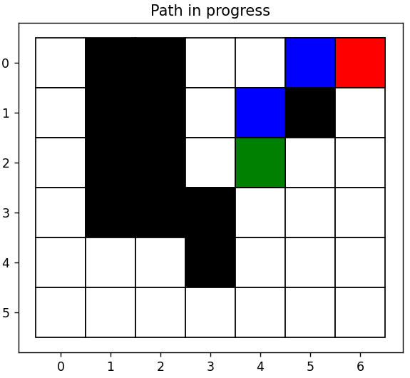

* No path was found at the end as the obstacles covered the goal.

**Informed RRT*:**

* Informed RRT* is the further optimized version of RRT*.
* The major flaw of RRT* being its tendency to explore and rewire all the space.
* Informed RRT* on the other hand only add nodes and rewire where there are more chance of finding a better optimum path.
* After a path is found, Informed RRT* only add nodes in the ellipsoid region formed by the path making sure the new nodes are added where they are needed to find a better solution.
* Following were the results obtained by applying RRT* and informed RRT* on the given map.

RRT* Informed RRT*

* It can be seen from the above two graphs that RRT* added nodes everywhere whereas informed RRT* explored more in the ellipsoid region.
* Thus informed RRT* was able to find a better optimal solution for the same number of nodes explored.